**History**

* **V1.1 2019-12-09 update for T1-Lite: disable demo mode; Disable automatically sync data**

**-------------------------------------------------------------------------------------------------------------------------------**

**Prepare test resources**

e.g. : adb -s 9fe3230e push StabilityResource /sdcard

* **common.ini**

**[Default]***; 2G3GLTE in Irvine, 2G3G in Ningbo*NETWORK_TYPE **=** 2G3GLTE  
LOG_FITER **=** DEBUG  
*;TEST_TYPE = Stability Mini Endurance Endurance_mini*TEST_TYPE **=** Mini  
*#CHINA or US*SITE **=** CHINA  
  
**[Telephony]**ed8b1bf7 **=** 13250979831  
  
**[Message]**ed8b1bf7 **=** 13250979831  
  
**[Wifi]**wifi_name **=** Auto-korea  
wifi_password **=** Performance32  
wifi_security **=** WEP

1. set SITE to US
2. set your local NETWORK_TYPE
3. Telephony and Message:

just add the deviceid and phone number of sdevice

1. Set wifi account

* **Remove demo mode**
  1. **Click demo mode app if installed**
  2. **Disable all auto-demo settings**

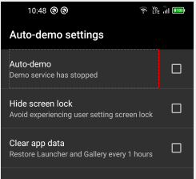

* **Play Store**

1. Sign in a google account, close the play store update for the first time.
   1. Disable automatically sync data(This is mandatory if login all DUT with same Google account)
2. open Gmail , TAKE ME TO GMAIL🡪Next🡪OK🡪Dismiss
3. open Chrome, Accept & continue🡪No thanks
4. App list-> sorting->by name

* **Take a screenshot**

Hold down the volume down button and the power button, and skip pop-up prompts

* **Settings**

1. Set all types of volume to minimum
2. Set Screen lock to None
3. Set Display🡪Sleep🡪Never
4. Open Developer options, enable “Stay awake”

* **Google**

1. sign in a google account
2. open Gmail , TAKE ME TO GMAIL🡪Next🡪OK🡪Dismiss
3. open

* **Contacts**

File Manager🡪Internal storage🡪StabilityResource

Open the vcf file of sdevice

Select Contacts and ALWAYS

Save imported contacts to Device

Enter Contacts app, click the icon shown below

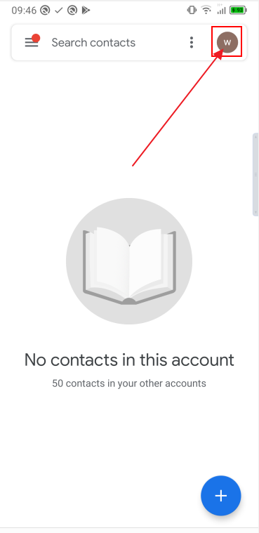

Select Device,

Click “Don’t back up”

Maybe you can not find menu above, just make sure disable automatically sync data when add Google account

* **Messages**

1. More options🡪Settings🡪Notifications🡪close
2. Create a SMS and send it to 1111
3. Create a MMS and send it to 2222

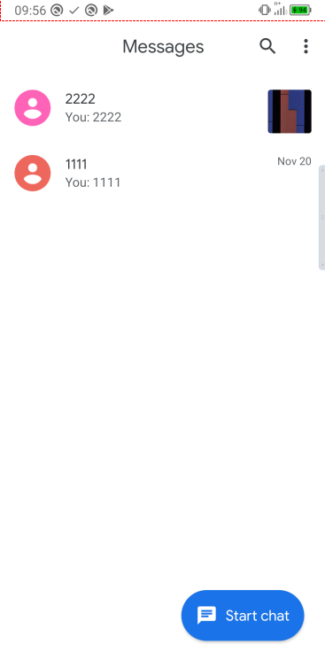

* **Camera**

Open camera, select “ALLOW ALL THE TIME”

* **Calendar**

Add an event , click “Add location”, select ALLOW ONLY WHILE USING THE app, then press back and home

Dismiss data sync

* **Sound Recorder**

ALLOW🡪ALLOW

* **Browser**

1. ALLOW🡪ALLOW ONLY WHILE USING THE APP🡪ALLOW
2. Delete default bookmark ”TCL”
3. Add 5 commonly used websites to bookmarks

E.g.:

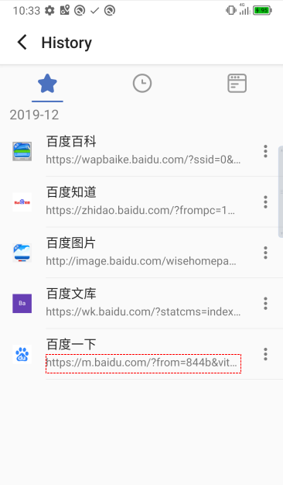

1. Quit Browser, select “Clear history & cache” and “Don’t ask again” , the click CONFIRM

* **YT Music**

1. Select DEVICE FILES ONLY(If you can not find this menu, restart and try again)
2. Songs🡪ALLOW🡪ALLOW
3. Back to YT Music homepage, and enter Songs again.